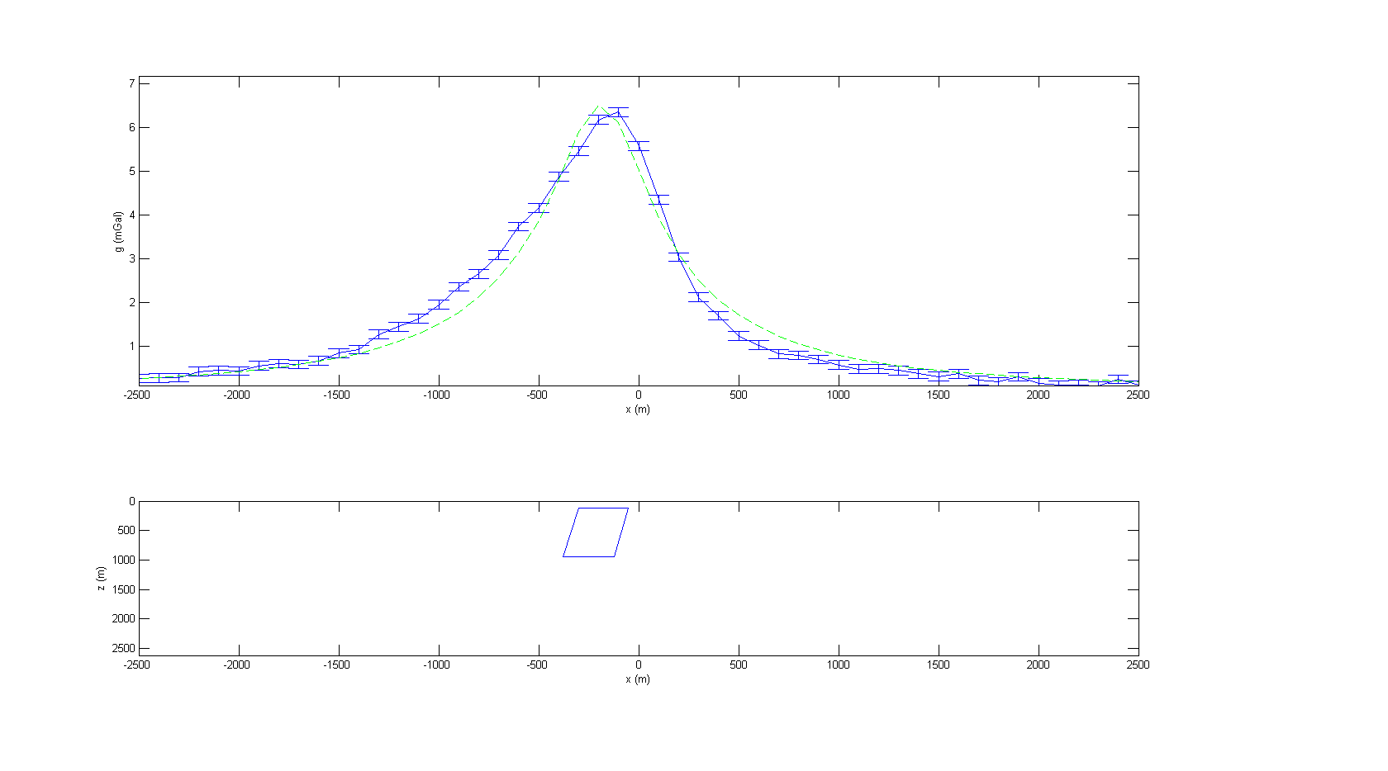

The dipping slab model does not fit the data for observation 2. The peak is roughly 100 meters to the left of the observed peak. The left side is too concave; it decreases too quickly. The right side is not concave enough; it decreases too slowly.

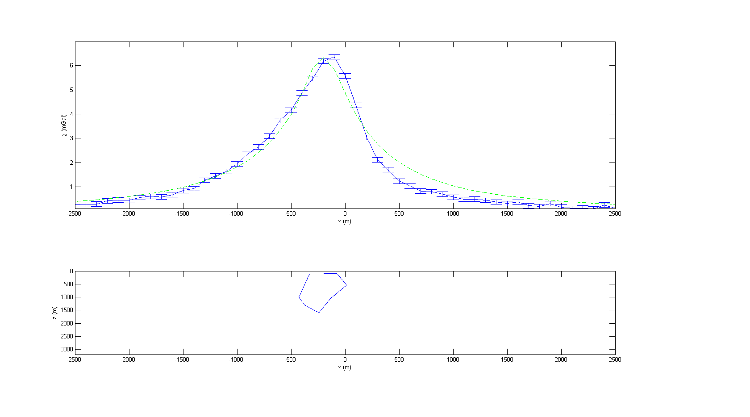

The polygon model fits the observed data better, but is still not quite right. The peak is still 100 meters left of the observed peak; however, the left side seems to fit the observed data and is much more accurate than the first model. The right side is still not as concave as it needs to be; it decreases too slowly.

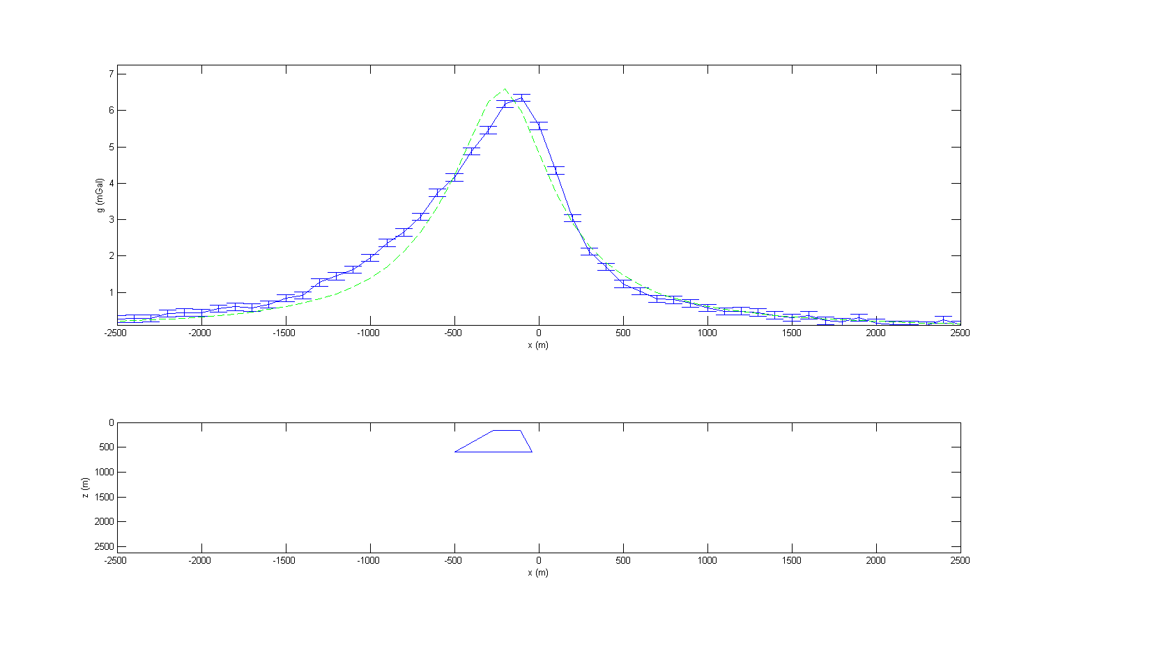

The third and final model consisting of a flat top still does not fit the observed data. The peak is still 100 meters too far to the left, and is too large. The left side doesn’t fit, it is too concave; increases too quickly. The right side fits a little better, it’s pretty close.

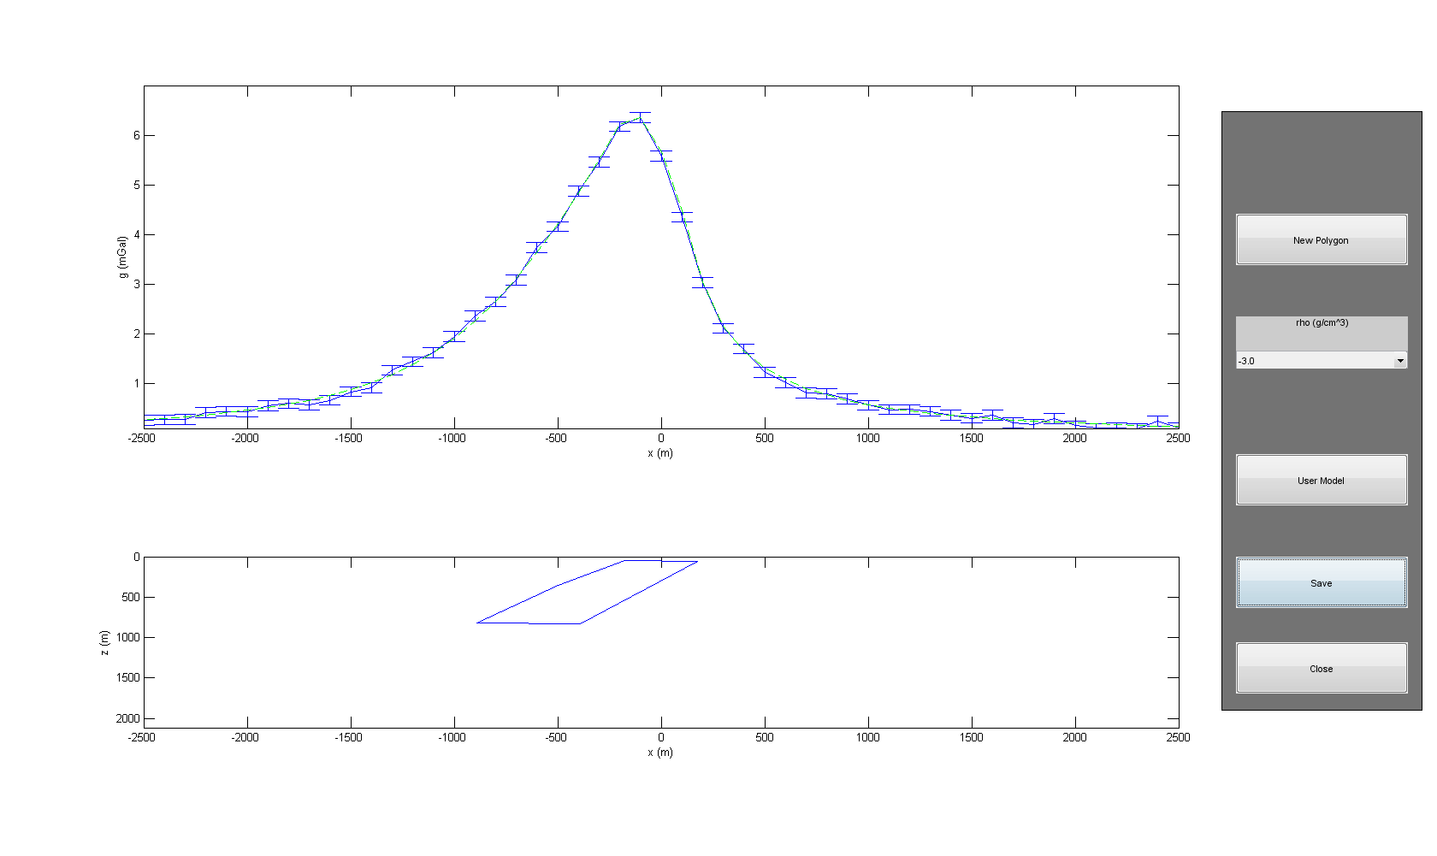

To improve our polygon from step 5 we made it much broader and closer to the surface. It also dips from right to left and the bottom and top are offset further than our polygon in step 5.